1. **Creating branch locally**



2. .**To switch between branches use git checkout I Remember to make use of the completion of branch names**

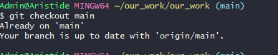

**3.Viewing branches**



**4.Create and checks the created branch**



**6. To ensure that the rename was successful, retrieve the current status of the branch using the “git branch -a” command** 